|  |  |
| --- | --- |
| Student Name | Om Atul Mahadeokar |
| SRN No | 202200340 |
| Roll No | 17 |
| Program | Computer Engg. |
| Year | Third Year |
| Division | B |
| Subject | Computer Network Laboratory (BTECCE21506) |
| Assignment No | 1 |

Assignment Number - 02

**Title :** Study of Linux and Windows Network commands

**Problem Statement** Studying Linux and Windows network commands. [ ping, pathping, ipconfig/ifconfig, arp, netstat, nbtstat, nslookup, route, traceroute/tracert, nmap, etc]

**Try to execute following commands on linux terminal or Windows command prompt.**

* + **Ipconfig / ifconfig**
  + **ping**
  + **Tracert/Traceroute/Tracepath**
  + **Finger**
  + **NSlookup**
  + **Netstat**
  + **Hostname**
  + **Port Scan / nmap**
  + **Arp Route**
  + **Whois**

**Theory :**

1. **Ping**: This command checks the connectivity between your device and another device on the network by sending ICMP echo requests and measuring the response time. It's useful for troubleshooting basic network connectivity issues.

2. **Pathping**: A combination of ping and tracert, pathping sends packets to each router on the way to a final destination and provides information about packet loss at each hop. It's available on Windows.

3. **ipconfig/ifconfig**:

- *ipconfig (Windows)*: Displays the IP configuration of network interfaces, including IP addresses, subnet masks, and default gateways. It also allows you to release and renew DHCP leases.

- *ifconfig (Linux)*: Similar to ipconfig, it displays and configures network interfaces. It can also be used to assign IP addresses and bring interfaces up or down.

4. **Arp**: The Address Resolution Protocol command is used to display and manipulate the ARP cache, which maps IP addresses to MAC addresses on the local network.

5. **Netstat**: Displays network statistics, including active connections, listening ports, routing tables, and network interface statistics. It's useful for diagnosing network issues and monitoring network traffic.

6. **Nbtstat**: Specific to Windows, nbtstat is used for troubleshooting NetBIOS over TCP/IP, displaying NetBIOS name tables for both local and remote devices, and resolving NetBIOS names.

7. **Nslookup:** This command queries DNS servers to find the IP address associated with a domain name (or vice versa). It's useful for diagnosing DNS issues.

8. **Route**: Displays and manipulates the routing table. It can be used to view or change the path that network traffic takes to reach a specific destination.

9. **traceroute/tracert:**

- **traceroute (Linux)**: Traces the path that packets take to reach a destination, showing each hop along the way. It's useful for identifying where delays or failures occur in a network.

- **tracert (Windows)**: Similar to traceroute, this command also traces the route packets take to a destination, showing the time it takes for each hop.

10. **Nmap**: A powerful network scanning tool used to discover hosts and services on a network. It can be used for network inventory, managing service upgrade schedules, and monitoring host or service uptime.

These commands are fundamental for network troubleshooting and analysis in both Windows and Linux environments.

**Output :**

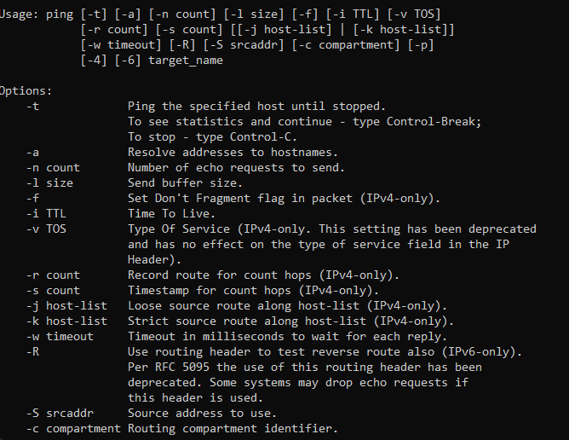

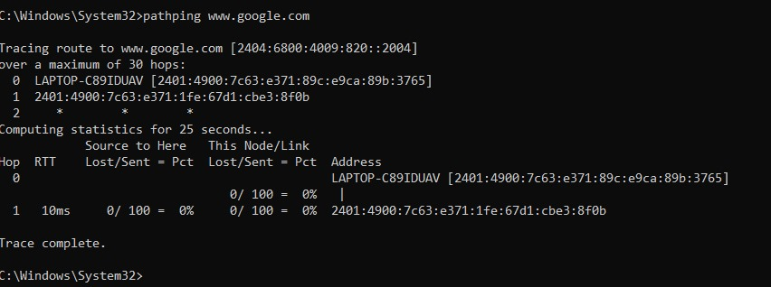

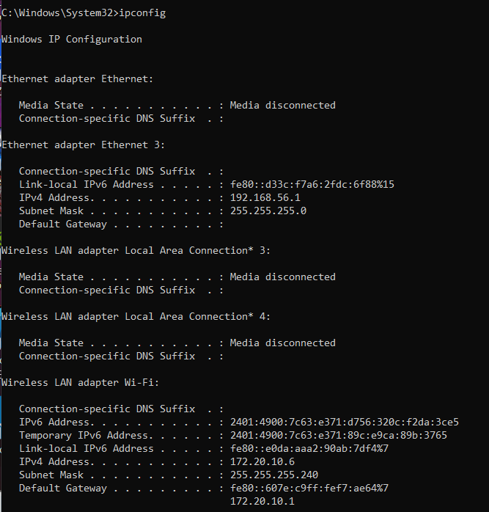

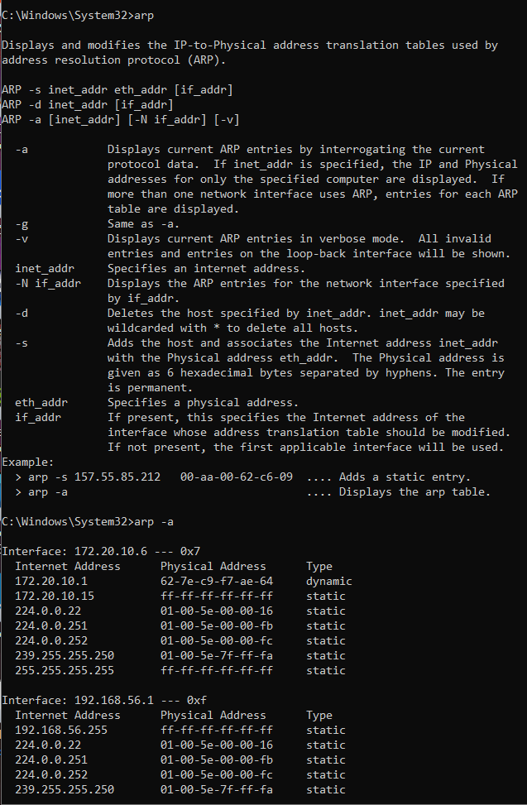



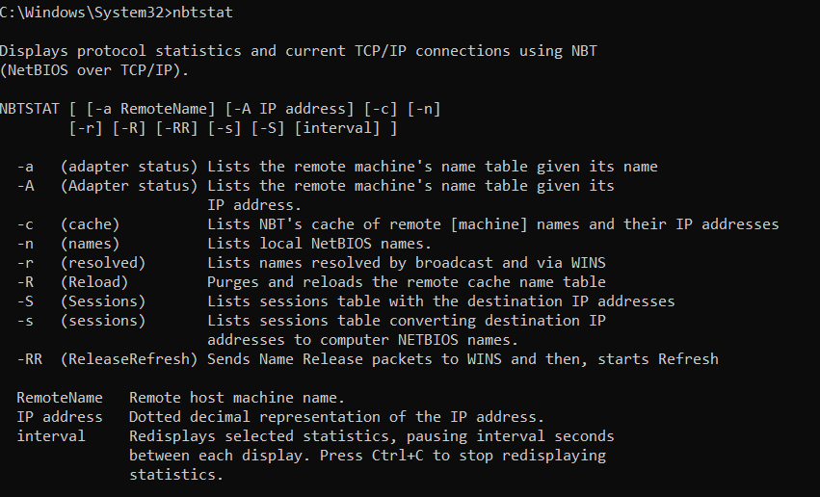

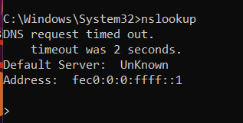

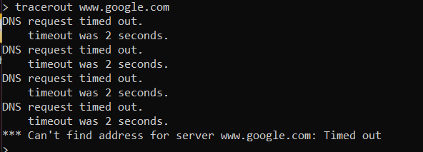

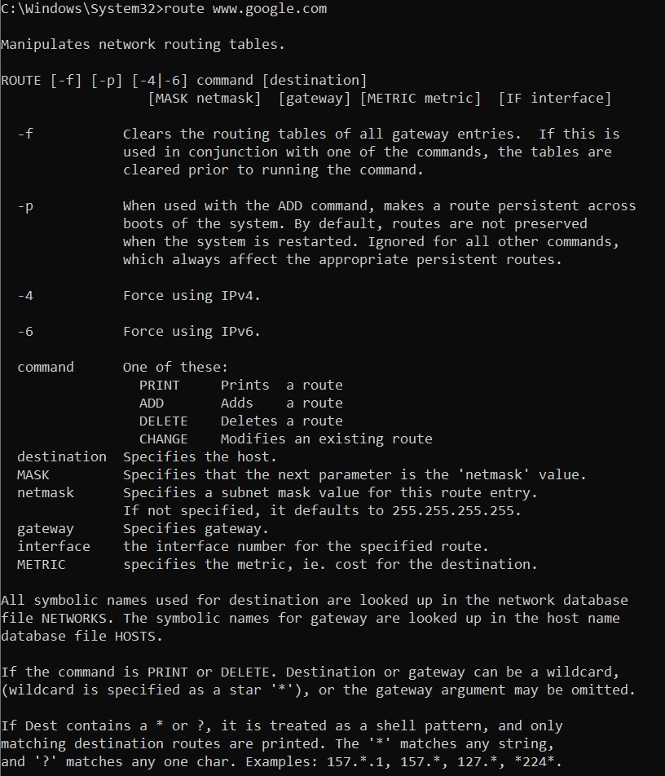



**Conclusion :**

These network commands are essential tools for diagnosing and managing network issues in both Windows and Linux environments. They help you check connectivity, analyze routing paths, configure network interfaces, and monitor network traffic. Understanding how to use each command allows for effective troubleshooting and optimization of network performance. Mastery of these commands is crucial for anyone involved in network administration or IT support.